$\vec{v}$$\vec{w}$$\vec{v}$1.1

1.5
Q
P
R
Q
P
R

1.6 1.7
P
Q
S
R
b
a

1.9 1.12
P

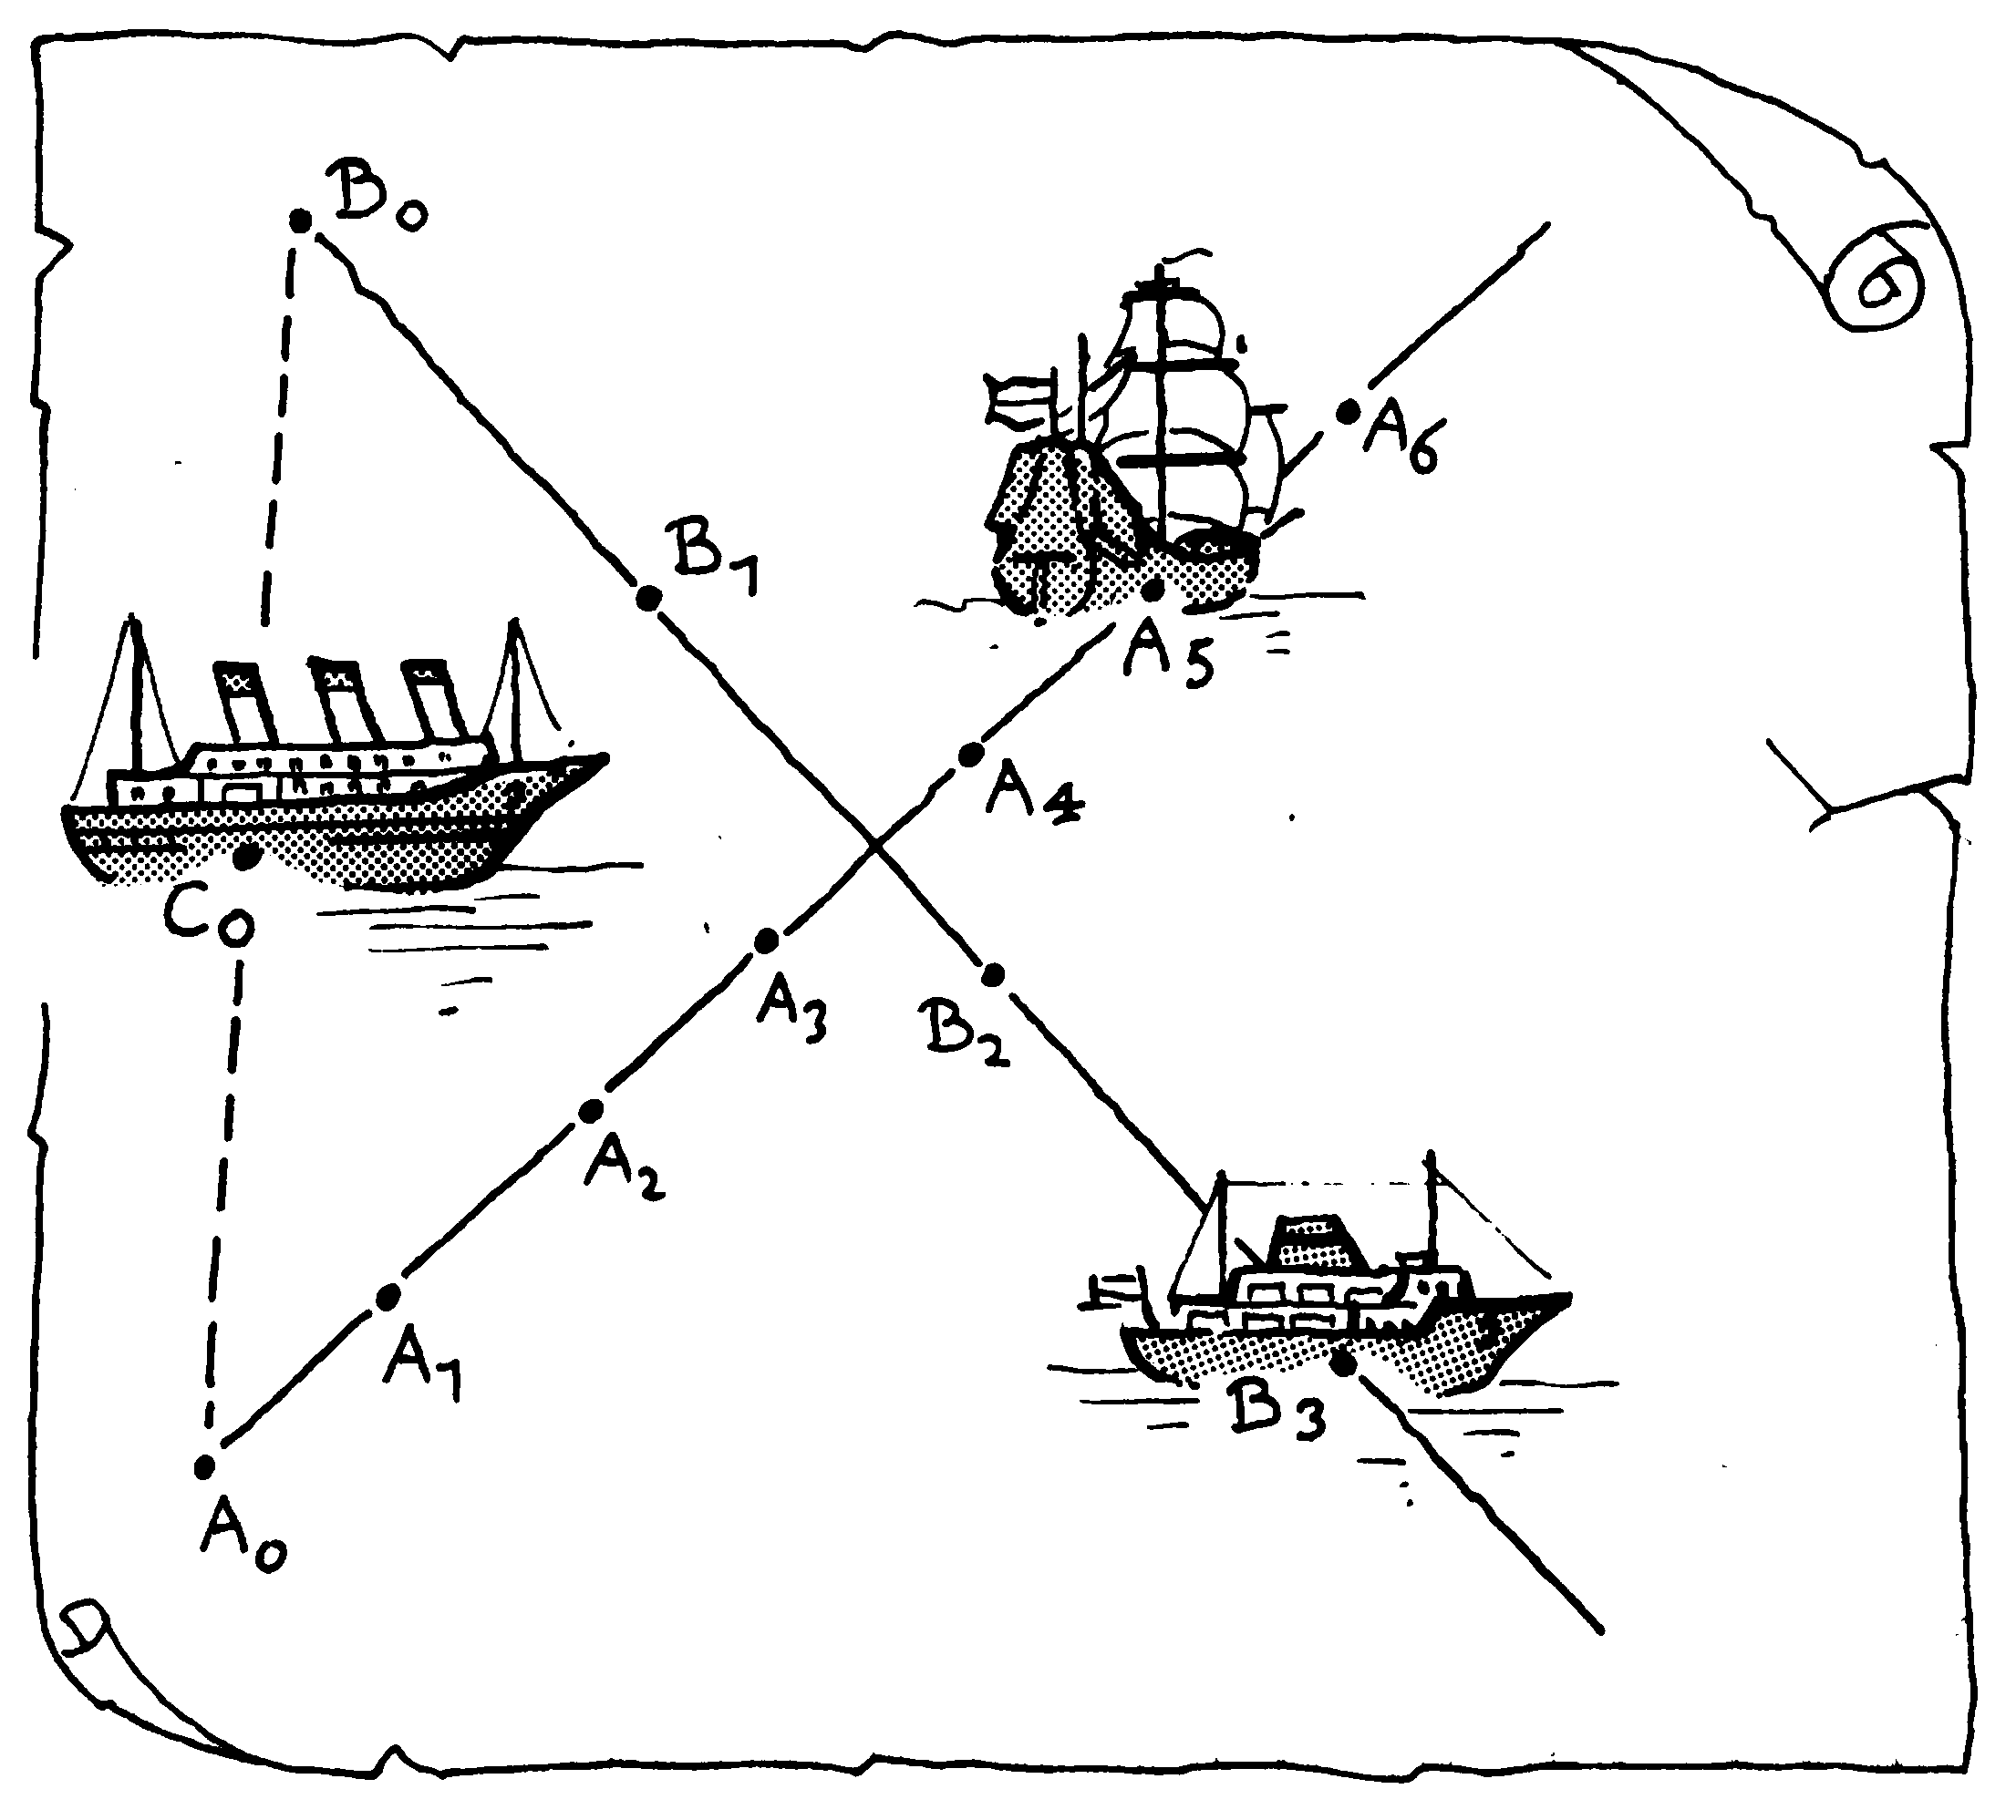
2.7

b
a
2.10

a
b

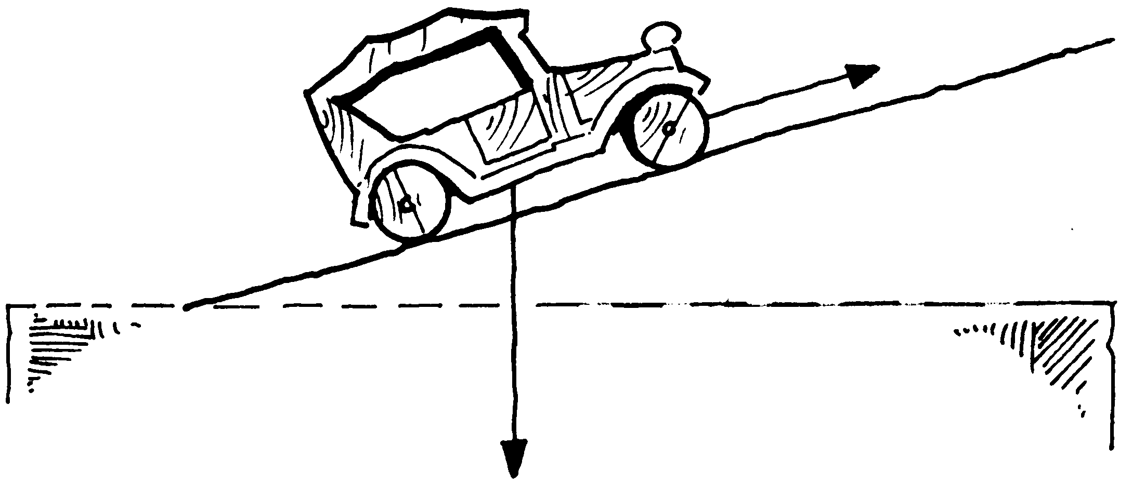
2.11

y-as
x-as
-2
-2
2
2
y-as
x-as
-2
-2
2
2
y-as
x-as
-2
-2
2
2
3.1

2
1
3
4.2 4.8
◎     

◎   
◎   
◎
◎
◎ 
◎
◎
◎

O
A
B
C
A
B
O
4.9 4.10

