The mathematics of running in the rain
An exercise in modelling
In our model we suppose the human body is a rectangular box, just like sponge Bob. Raindrops are falling straight down with vertical speed $v_{r}$. Sponge Bob is moving at a speed $v_{p}$ towards shelter.
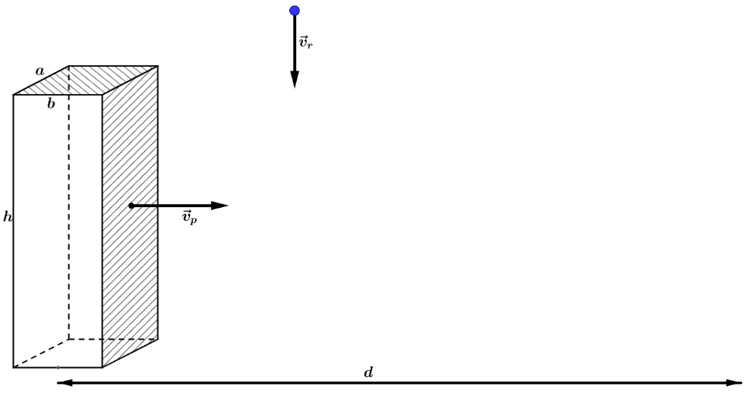
With Bob as a reference, the velocity of the raindrops is $\vec{v}=-{\vec{v}}_{p}+{\vec{v}}_{r}$ as shown below.
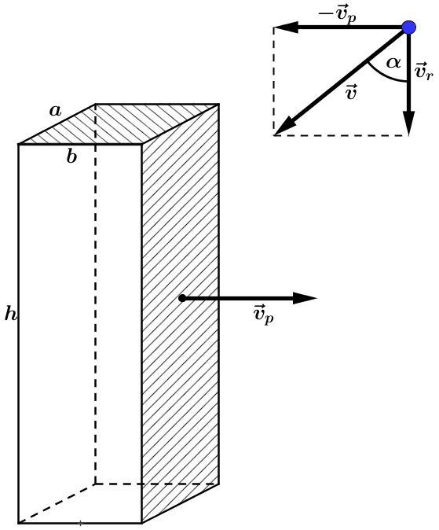

We search for a formula for the total mass $m$ of water that Bob absorbs, as a function of $v_{p}$.
First we explore two limit situations.
- How much water Bob absorbs if he moves at an extremely low speed? In other words: what happens to the mass $m$ if $v_{p}→0$ m/s?

- How much water Bob absorbs if he moves extremely fast? For example: his speed is one tenth of the speed of light ($c≈3⋅{10}^{8}$ m/s). Suppose $d=100$ m and $v_{r}=3$ m/s.

Now we search for a formula for $m(v_{p})$.
- Determine the length $v$ of $\vec{v}$.

- Find a formula for $α$ if you know the value of $v_{p}$ en $v_{r}$.

- Suppose $y$ (kg/s) is the mass of water that comes down at Bobs head and shoulders (thus at the top of the box) in one second. What’s the total mass of water that comes down at the top of the box during the interval of time in which Bob is running to shelter? Denote this by $m_{B}$.
- Suppose mass density of the rain is homogeneous. Denote by $z$ ($m^{3}/s$) the volume of water that comes down in one second on the head and shoulders of Bob. Write $y$ as a function of $z$ and substitute this in the formula for $m_{B}$.

- Find a formula for $z$, the volume of water that comes down in one second on the head and shoulders of Bob. This volume is a parallelepiped; draw it.

- Substitute the formula for $z$ in the formula for $m_{B}$.

- Prove: $m_{V}=ahdρ$. In this formula $m_{v}$ is the mass of rain swept by the front face of Bob.

- $m_{V}$ does not depend on $v_{p}$, $v_{r}$ or $v.$ Does that makes sense?

- Write $m {as function of v}_{p}$.

- Which type of function do you find for m($v_{p}$)? What are the asymptotes of this curve?

- Plot $m\left(v_{p}\right)$ for the following values: $d=100$ m, $v_{r}=2$ m/s, $a=0,20$ m, $b=0,50$ m, $ρ=2$ kg/m³ and
$h=1,80$ m. What is your conclusion? Should you walk slowly or run as fast as you can?
Is there an optimal speed in this model?

- Is this model very realistic?

- Does leaning forward improves your chances of staying dry?

