Manual of Session 1 on the Language of tables and graphs

Basic idea | Lamavoc aims to develop a teaching approach and teaching units for workplace-related and language-integrated mathematics learning. One of the teaching units is about the language of tables and graphs. In this first session teachers are made aware of the relevance of language in math teachting in general and more specific the language related to graphs (diagrams) and tables. The focus is on diagrams and graphs of situations: some of these are vocational, while others are of general interest (from everday live). This session forms the basis for the other two PD sessions on this topic.
Target group | Teachers on numeracy (and mathematics) in (pre)vocational education.
Core activity | In this PD session the focus is on general background of language sensitive teaching and on the the cursory part of the teaching unit (Part B). By analysing one of the worksheets and student work on this, teachers are made aware of and learn about the relevance of language for the understanding of graphs, diagram and tables and diffficuties student may encounter and how to overcome these.
PD Material | - This manual (worksheets are attached to it)  - The presentation: .pptx  - The unit: The language on tables and graphs
Other requisites:
- Laptop, Beamer

Possible schedule for a 2,5 hour PD session (other schedules possibile)

Time | Activity |  | Material
Part 1: | Introduction (10 min)
7 min | Discussion about a bar graph from the news or another example. Teachers tell what information they see in the graph in a correct and understandable way. Ask participants to reformulate vague‘ utterances. |  | Ppt sheet 2
3 min | Show the program of the 3 sessions and this first session |  | Sheets 3 and 4
Part 2. | About the relevance of language for mathematics (45 min)
10 min | Background on language-sensitive teaching (part 1)- interactive presentation. |  | Sheets 5 - 12
15 min | Activity: analysing a textbook task  Participamt work small groups of 3 – 4, have each group make notes. |  | Worksheet 1 (in this doc)  Sheet 13
10 min | Whole group reflection: collecting and discussing results ort h analysis |  | Sheet 14
10 min | Presentation on language-sensitive teaching (part 2).  The example of student difficulties (sheets 17 & 18) may be done in interaction with the participants |  | Sheets 15- 20
Part 3. | Background of the unit (15 min)
15 min | Present the unit and its background.  You may also have teachers look at pgae 9 (overview of activities) or flip through part 2 of the unit starting on page 30. |  | Sheets 21-28
Part 4. | Activity using worksheets and student work (30 min)
10 min | In small groups teachers do the tasks on the worksheet (9 in the unit) themselves. They reflect on the language demands and expected student difficulties. |  | Sheets 29 + 30 Worksheet 2
20 min | Think Pair Share using student answers |  | Sheet 31  Worksheet 3
Part 5 | Scaffolding (10 min)
10 min | Present and dicuss scaffolding as a means to support students language |  | Sheets 32-35
Part 6 | Teaching practice (30 min)
15 min | Teachers (in the whole group) discuss to what extend and in what way they apply a language senstive approach in their own teaching practice |  | Sheets 36 and 37
15 min | In small groups teachers start to design a language sensitive teaching activity to try out in their class (finihing the design and trying it in class is howmework fort he next session) |  | Sheet 38 (and 40)
Part 7 | Reflection and looking forward
10 min | Look back an reflect on this session (you may have teachers write a tip and a top) and look forward and present the homeworktask |  | Sheet 39 -41  Worksheet 4

Open source | We love to share the materials. Please (re)use the materials under the CC-BY-SA licence (https://creativecommons.org/licenses/).
Further reading | - Swan, M., Pitts, J., & Fraser, R. (1985). The language of functions and graphs. An examination module for secondary schools. Manchester: Shell Centre for Mathematical Education. https://www.mathshell.com/publications/tss/lfg/lfg_teacher.pdf  - Wijers, M., & Jonker, V. (2019). The language of graphs and tables. Language-oriented mathematics teaching in professionally oriented contexts. Paper presented at the Educating the Educators (third international conference), Freiburg, Germany.  www.fi.uu.nl/publicaties/literatuur/2019_presentation_ete_freiburg_lamavoc_graphs.pdf

Worksheet 1 Analysis of a textbook task
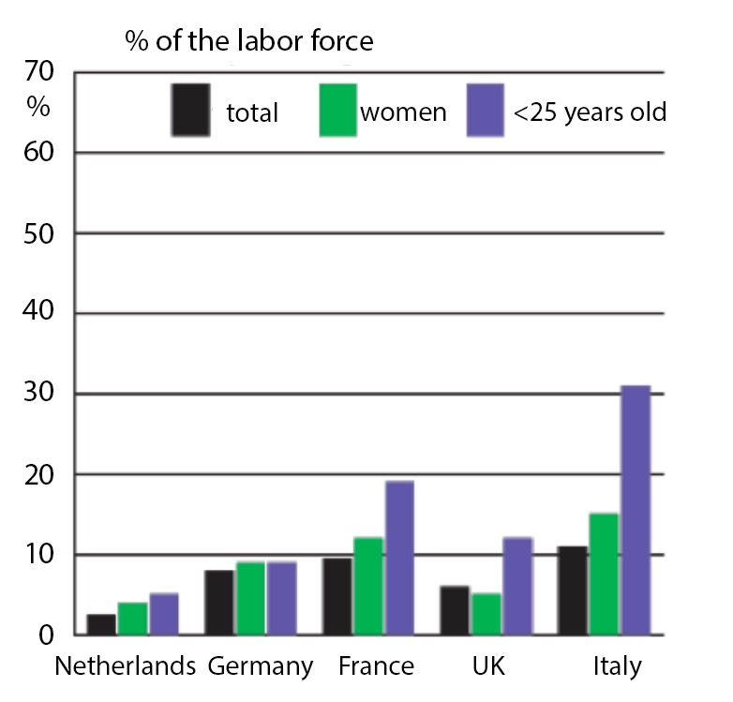
a. Which country has the lowest unemployment rate?
b. What percentage of the labor force in France is unemployed?
c. Which country has an unemployment rate of approximately 11%?
d. Which population group has the highest unemployment rate in all countries?
e. What percentage of the Italian labor force under the age of 25 is unemployed?
Unemployment in Europe (2000)

In small groups analyse this task:

- What types of language are used in the unemployment task?

- Look at the problem through the eyes of the students: what might be difficult for them?

Worksheet 2 – student activity from the unit

Lesson 1 – Worksheet 2 – Reading a diagram, interpreting and describing it Version green

Look at the diagram below together.
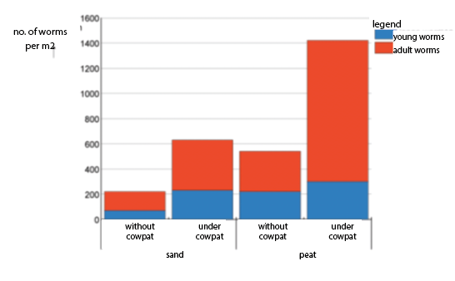
Discuss and answer the following questions

- What is the name of this type of diagram?

- What do you see in this diagram? Do you know the meaning of all the word?

- Explain to your neighbour what the diagram is about. What is the story?

- Come up with a fitting (short) title for this diagram.

- Fill in words that make the sentences match the diagram:

Most … ………… worms can be found in ….……………. ……. Cowpat.

Cowpat is … …………. for worms.

- Come up with a question that can be answered using he information from the graph.

Look at the diagram again.

- What parts does this diagram have? Make a list or write the names of the parts in the diagram.

- With a partner do the tasks on this worksheet
- Reflect on the language needed
- What students answers and difficulties do you expect?

Worksheet 3 – students answers on part of worksheet

Students answers of the question: what is this diagram about?

Student 1:
Number of worms in the cowpat
Young/adult worms

Student 2:
About cowpat and sand and peat

Student 3:
How many worms there are in different types of sand

Student 4:
Number of worms per m²

Student 5:
About worms in something the number

Student 6:
How many worms can be in diferent types of soil

Student 7:
There are worms in the table per m²

- Individually: order the students' answers from best to worst

- In pairs: share your orderings and your reasons behind it and together make a list of language related difficulties the student work shows.

Worksheet 5 - Lesson prepration and evaluation form

Name
School
Type of class |  | grade
What activity did you design and use?
Give a brief description of resources, characteristics of the context and the diagram/graph/table.
What are the mathematical content, concepts and goals for the activity? What task(s) do you give students?
[add teaching materials as an appendix]

What is it that makes the activity language-sensitive?
What are the linguistic demands in this activity and what goal(s) do you set related to the use of (mathematical) language?

How do you plan to activate your students in producing language in this activity? What language support do you provide?

Experiences during the lesson: what student behavior did you observe (different than normal)?
How did your students react to the activity?
What did you observe with respect to language aspects?

[add student work as an appendix]

