A tool for analysing change
Paper for ISDDE 2008
Frans van Galen
Freudenthal Institute for Science and Mathematics Education
Utrecht, the Netherlands

How sunflowers change
The graph in figure 1 shows the growth of a sunflower. We can interpret this graph as: the sunflower starts to grow slowly, grows faster and faster until, at a certain moment, the speed of growth starts to decrease again; some time later the sunflower reaches its final length. To be able to interpret a graph this way, one has to understand quite a few things:
- The line is a collection of points; each point shows the length of the sunflower - in cm - at a certain point in time.
- The graph is probably based on a certain number of measurements, but as such it is a generalization: it gives the length of the sunflower at every point in time.
- To grow ‘slowly’ or ‘fast’ means that within a given period of time the change in length is small, or comparatively large.
- The values on the two axes are ordered and the distances on the axes are meaningful
In education it is not uncommon to present students examples of line graphs and then help them with interpreting these. Freudenthal (1973) however, would have called this an ‘anti-didactical inversion’. According to the theory of Realistic Mathematics Education (RME), we should start at the other end and let students ‘reinvent’ the idea of a line graph, in a process called ‘guided reinvention’ (Freudenthal 1973; Gravemeijer, van Galen and Keijzer, 2005)

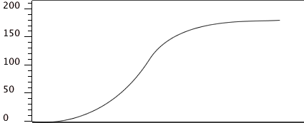

Figure 1. The growth of a sunflower.

In our project ‘Mathematics education for the information society’ we develop a computer tool that is meant to help students to go from an elementary understanding of measurement to understanding sophisticated representations such as line graphs. The student projects we have developed so far can be found at http://www.fi.uu.nl/rekenweb/grafiekenmaker/
The basic representation in the computer program is the bar. The length of the sunflower, for example, can be represented as a small bar, with an axis besides the bar to tell the length of the sunflower in reality, see figure 2. The student can start with a series of ‘pictures’ of individual measurements, ordered in time and together forming something like a movie strip.

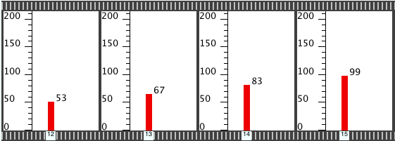

Figure 2. A movie strip of individual measurements.

The measurements can also be shown in a window with only one vertical scale, see the upper part in figure 3. The little window at the bottom can show the ‘movie’ of how the length of the sunflower changes over time. A colouring of the corresponding bars in the upper window runs along with the movie.

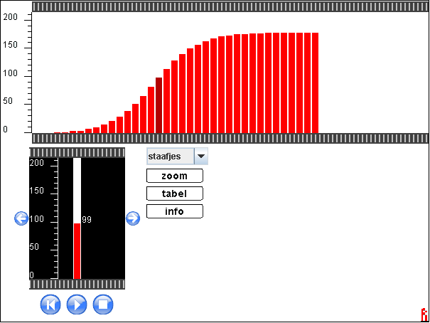

Figure 3. The bars placed next to each other. Below is the ‘movie’ window.

It is possible to rescale the axes. This is useful when there are over 50 measurements, as the bars always have the same thickness originally. The example of figure 4 comes from a version of the tool that takes data from a temperature sensor as its input. While students are measuring the cooling off of a cup of hot water - one measurement per second - the bars appear one by one as shown in the upper part of figure 4. When the window is full, all bars move to the left so there is room for a new bar at the right. Afterwards it is possible to rescale the graph and fit all measurements within the window - see figure 4, lower part.
The rescale option has a function in the learning process. Students can play with stretching and shrinking the horizontal scale and grasp the idea that a line graph is basically a graph with an infinite number of data points.
The assumption is that by experimenting with the computer tool, students later will be able to ‘see’ as it were the bars under a line graph, and use this in their reasoning. In our student tasks the horizontal quantity so far always has been time, but it can also be a different quantity.

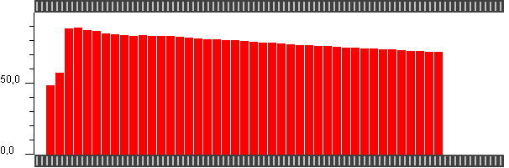

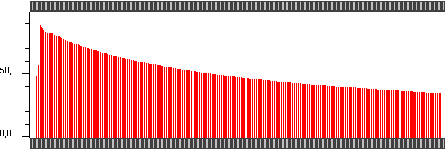

Figure 4. The cooling off of a cup of hot water. Above is shown how the bars appear while the measuring is done. Below is shown how the graph is rescaled to fit all bars within the window.

Guided reinvention
In this paper I want to discuss and illustrate the relation between ‘guided reinvention’ - a core concept in RME - and the daily handiwork of the designer. Guided reinvention refers to the fact that mathematical concepts and procedures have come about in a process that took ages. To some extent students should go through the same invention process. Of course this process needs guidance - by carefully chosen problems and by the teacher - as a history of ages has to be compressed into a couple of school years. Not necessarily the learning process of students should follow the path of history, but the history of mathematics may be a source of inspiration for the designer as it shows us what people have been struggling with.
The ideas written down in our project plan, sketch - in a very rough form - an education theory for the specific domain of learning to understand and work with graphs. It contains presuppositions - so far quite implicitly - about the concepts that students in grade 5 will have mastered and hypotheses about the way students may go from there towards understanding complex representations.
In the actual construction of a tool and student tasks a multitude of design decisions have to be made, a few big ones, and many small ones. These decisions follow the overall concept of guided reinvention, but there is a large gap between the general principle and the actual realisation of a learning trajectory. In other words, many different routes are possible. The decisions concern (1) the details of the computer tool and (2) the choice and the actual realisation of context problems Some of these decisions are taken ‘on the fly’, but many others after serious consideration and discussions, and sometimes also on the basis of experimenting with a prototype. To design is to experiment: doing thought experiments, playing with prototypes and experimenting in real classrooms.
In the paragraphs that follow I want to illustrate the design process by describing examples from our project.

Bars
Starting point in the development of the tool was our belief that a representation of measurement data as individual bars would support the way students reason about change. It is not an idea that lends itself easily for testing in a comparative experiment, but while experimenting with the student tasks we are continually at the lookout for data that support or undermine such an idea. At this moment our data are anecdotic, but they strengthen us in the belief that the direction we have chosen is a valuable one.
Confirmation was found, for example, in the discussions we had with students of grade 5 and 6 about graphs that were produced in the computer game of ‘Engine Driver’. A screen of this game is shown in figure 5. A train is shown as a small red dot that travels over the railway track. With the arrow buttons at the lower right corner the train can be speeded up or slowed down, and this can be done both slowly (with the single arrow buttons) or fast (double arrows). Purpose of the game is to finish the track in the shortest time possible, but to stop at each station and not to exceed the speed limit of 150 km per hour.

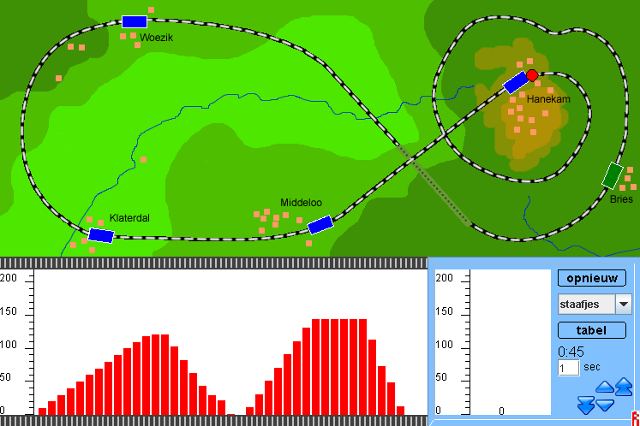

Figure 5. The screen of ‘Engine driver’

When we questioned students about the graphs and asked them about the difference between speeding up slowly and speeding up fast (first and second part of the graph in figure 5), they could easily explain this in terms of the bar length. You can see, they said, that in the second part of the graph the difference between every two bars is about 20 km, whereas it is only 10 km in the first part. This means that in one second - speed was measured once every second - the speed of the train changed 20 km per hour, compared to only 10 km per hour in the first part of the graph.
Describing change in a line graph will require a more abstract phrasing like: ‘in an equal period of time the speed has increased more’. The concrete representation of speed as the length of a bar will guide students towards a more formal understanding.

Zooming
To a certain extent the scaling on the vertical and horizontal axes is arbitrary. In our hypothetical learning trajectory (a term coined by Simon 1955) it is important that students experiment with changing the scale on the horizontal axis, and so develop the idea of a line graph as a collection of many data points, whether real or inferred. It is also important that they experiment with stretching the scale of the vertical axis, as this makes differences visible that would not have been noticeable otherwise.
In many computer programs scales are adjusted automatically if data do not fit in the window. In our view, however, it is important that students should change the scaling themselves, and do it as consciously and explicitly as possible.
The rescale option in our tool works differently from what is usual. Clicking on the rescale button brings up an extra screen in which the original graph window, with its fixed size, is shown as a white rectangle, see figure 6. The bars of all measurements are shown - in miniature - in another rectangle that can be dragged around. By pulling and pushing at a side of the data rectangle its form can be adjusted. This way, for example, it is possible to fit all bars within the white rectangle. By changing the height of the data rectangle the vertical scaling can be adjusted. Our presentation of the scaling is more concrete than the usual option to change the scale values as such. We hope that our version will prepare students for more abstract ways of handling scaling.

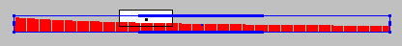

Figure 6. The rescale window.

A graph of differences
If a computer tool is to be a real tool, it should not only allow users to do new things, but it should also allow them to do the things they would have done without the tool. In our case a little experiment we did before the computer programs were ready, was very instructive. We videotaped a lesson in which the teacher told a story about how her father had measured his children on every birthday. She presented the class a data sheet with the measurements of her brother. Asked what they noticed about these data, the students said that her brother had grown more in his first years than in later years. The teacher then asked them to draw a graph of her brother’s growth that would show this difference in growth speed.

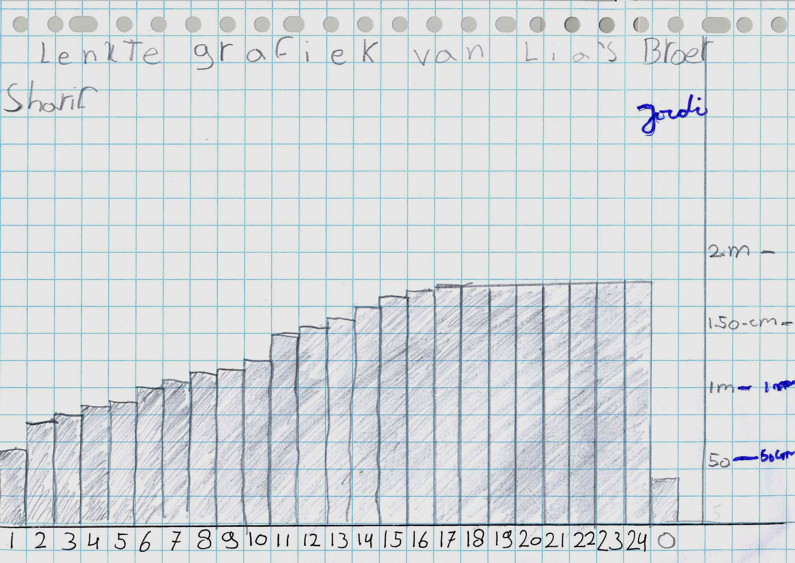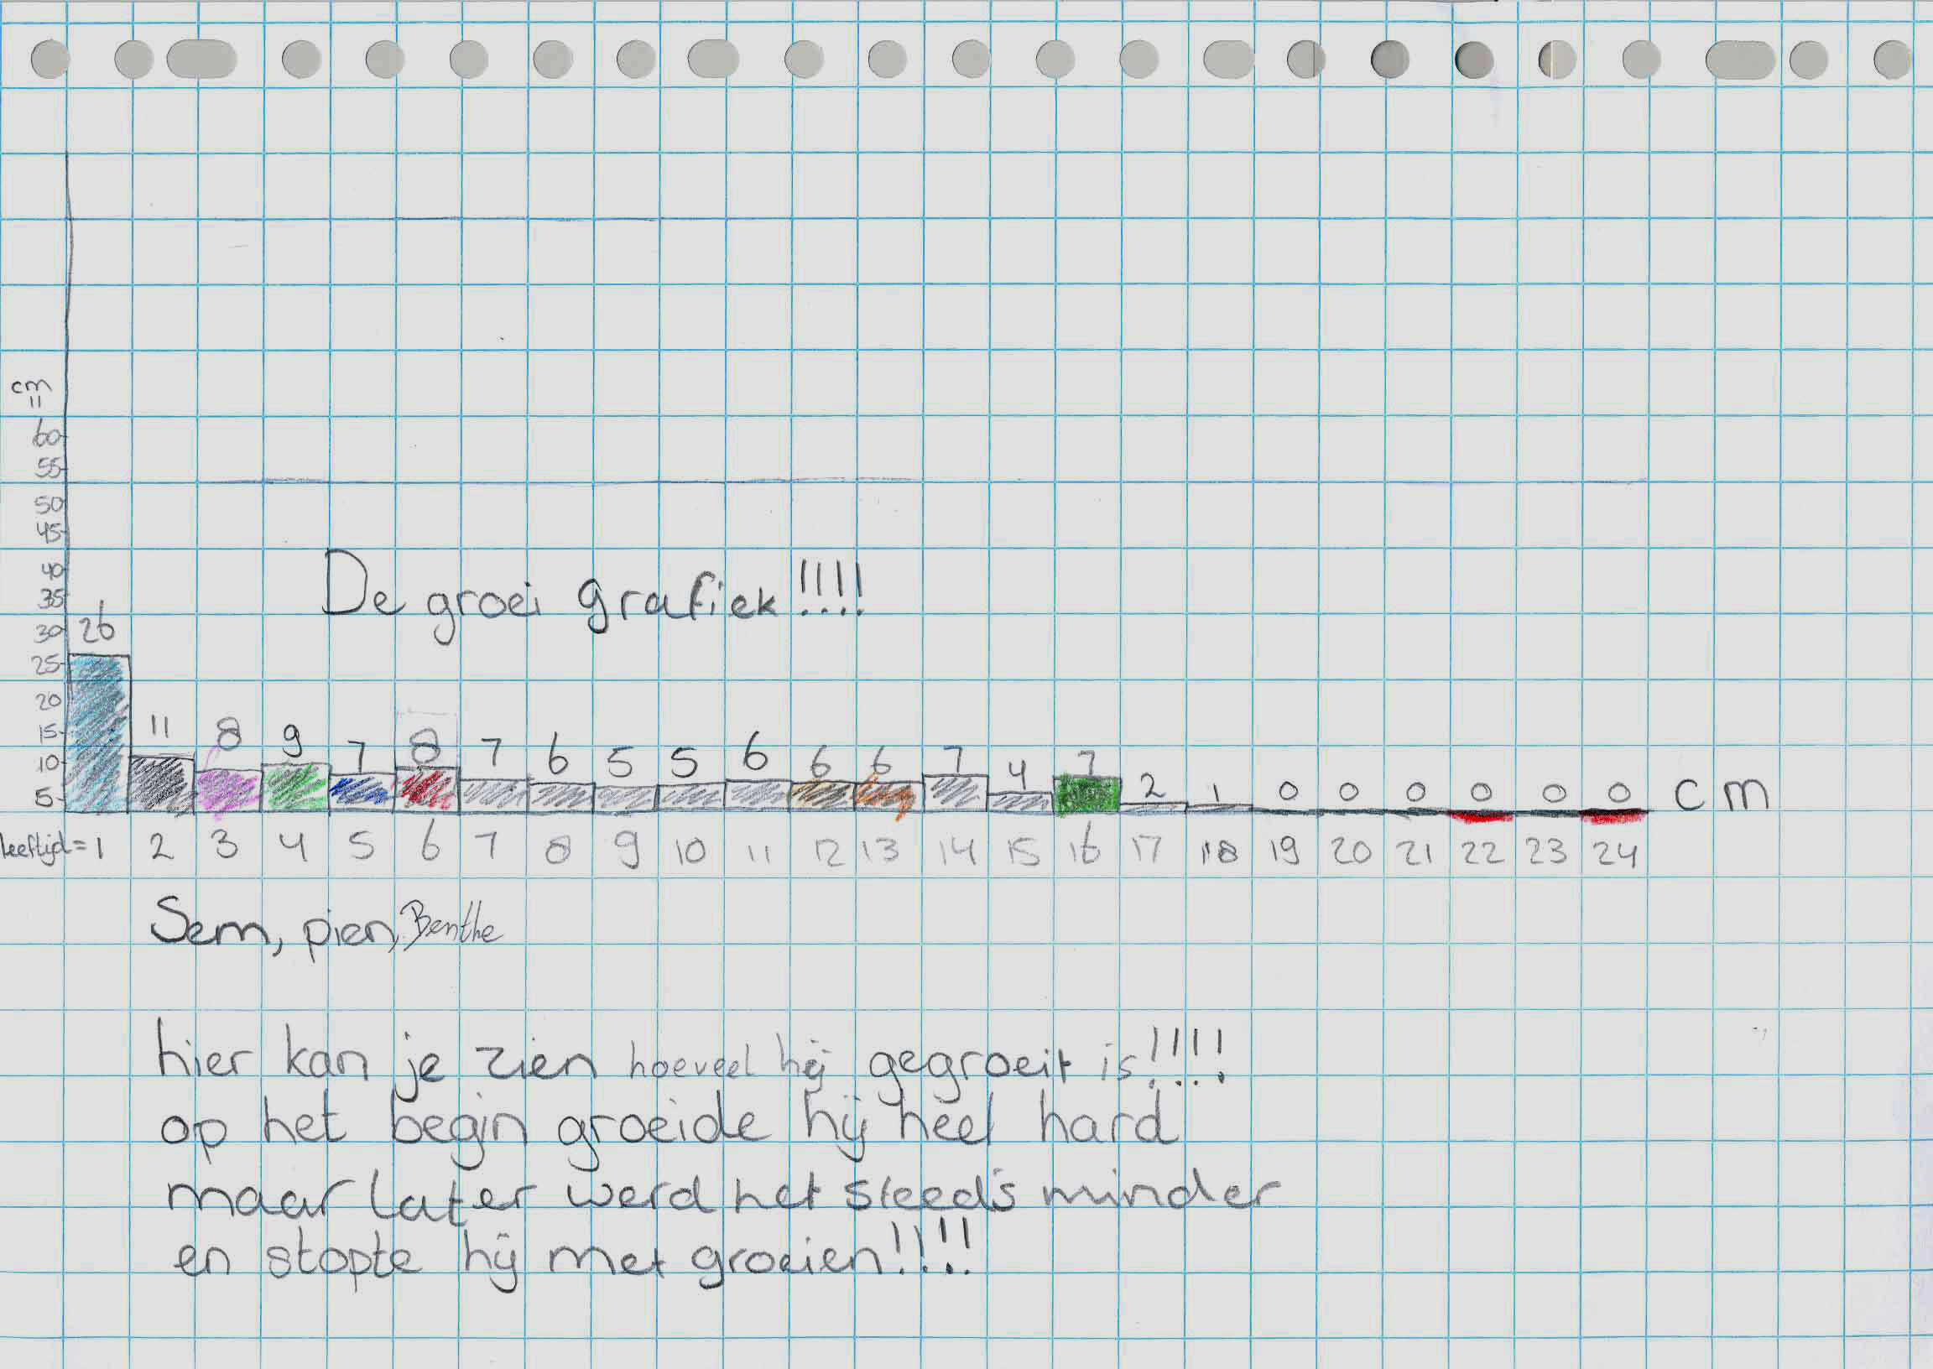

Figure 7. A bar graph of the length on every birthday (left) and a graph of the growth per year (right)

As could be expected many students drew bar graphs like the first one in figure 7. This particular one is interesting because the student had forgotten the length at birth, and added this after age 24, as if the order on the horizontal axis is not very important. Our point here, however, is that also many students drew graphs of the actual growth in one year, which means they drew graphs of differences. This, of course, is a very nice idea, as such a graph gives a more direct representation of change than a simple graph of lengths.
This finding told us that our tool should allow a similar graph. We have included an option in our tool that will draw bars of the differences between consecutive bars. As such, however, this is not yet a solution. The design problem we have to solve is how we bring students in a situation where the need for a graph of differences will arise in a natural way. If it remains just an option in the tool that students did not ask for, experimenting with the option will not lead to new insights probably.
One of the student projects we have developed is about body length. We hope that questions about the ‘growth spurt’ in puberty will evoke the want of an overview of growth per year.

Choice of context situations
It was clear from the start that the tool had to be suitable to analyse data measured by a sensor. We use the EuroSense sensor (http://www.cma.science.uva.nl/Hardware/CMA/interfaces.php?id=191) which can measure temperature, light and sound. It can be connected to the computer using the USB port.
There are many examples of science projects in which students have to measure temperature, light or sound, but not so many that involve comparing graphs showing a change over time. We have tested a task in which grade 6 students compared the cooling off of a small amount of hot water in different circumstances. They worked in couples and were free to choose the situations they wanted to compare. One pair of students, for example, poured hot water in an vacuum flask packed in freezer packs. Another pair compared the cooling off of salt water with that of water without salt.
One of the things we learned from this experiment is how practical considerations will decide whether or not a task will be incorporated into the curriculum. In this case the teacher said that he probably would not repeat the activity next year, as students had to work outside of the class, and because it was only possible to let one group work with the sensors at a time.
Compared to this, the ‘Engine Driver’ task has more chance to find a place within the school curriculum. In this task the data are generated in two to four minutes, the time needed to complete the track. Also the students are playing a game in that period, in stead of having to wait until the data are collected.
So although one could say that working with a sensor is the ‘real thing’, practical considerations play an important role in decisions about what student projects will be useful.

Conclusions
Developing a tool and student tasks around this tool gives us the bits and pieces for the ultimate task, which is to develop a learning trajectory. Tasks should be ordered in such a way that they give rise to discussions about the basic ideas behind graphical representations of change. A discovery in an earlier situation should be brought along when students try to solve the next problem. In the end students should really understand graphs, as they will have gained their insight step by step, and made these steps themselves. So far, however, we only have developed the bits and pieces. A lot still remains to be done.
In this paper I have tried to illustrate the many layers of decisions that have to be made within the design process of a learning trajectory that uses a computer tool. The tool we are developing will be an instructional tool, not a tool that offers the most efficient way to analyse and present measurement data. Important design decisions concern the interface of the tool, and the options it will offer. As important as that, however, are decisions with respect to the situations that students will be asked to explore with this tool.

Literature
Freudenthal, H. (1973). Mathematics as an Educational Task. Dordrecht: D. Reidel Publishing Company.

Gravemeijer, K.P.E., Galen, F.H.J. van & Keijzer, R. (2005). Designing instruction on proportional reasoning with average speed. In: H. Chick & J. Vincent (Eds.), paper presented at PME 29 (RF01), Melbourne: University of Melbourne.

Simon, M. (1995). Reconstructing mathematics pedagogy from a constructivist perspective. Journal for Research in Mathematics Education, 26, 114–145.

