Teacher Guidelines

Goal of this Webquest
The aim of the activities is that the students learn to interpret a graph as a representation of change. The computer offers advantages above the math textbook, because students can observe the graph as it is created. Another advantage is that the graph is connected to the students’ actions.

Overview
The webquest starts with a game in which the students have to let the train pass by stations along the train tracks as fast as possible. Factors that make this challenging are:
- You have to break on time for the next station. When the train continues too far, the Automatic Train Security (ATS) stops the train and lets it travel back to the previous station. That takes time.
- You may not let the train go faster than a certain maximum, for example 110 km per hour. When you go too fast, the ATS intervenes and that also takes time.
There are four different train tracks.
- In train track 1, students can only accelerate and break slowly. A graph showing the speed of the train appears on the bottom of the screen.
- In train track 2, there are two buttons for accelerating – slowly and quickly – and two buttons for breaking – slowly and quickly.
- Train track 3 is a simple circuit without any stations. For this train track, students answer questions. The track can be used to experiment.
- Train track 4 provides a graph of the distance covered by the train in stead of its speed

Game and activities
Be aware that students can be so engaged in the activity that they also try to complete the circuit in Tracks 3 and 4 as fast as they can, rather than answering the questions. You can tell them that they can return to the game later. The game can be found on www.rekenweb.nl.

The questions
The questions are meant for the students to find out what can be read off of graphs.
- The difference between accelerating slowly and fast
- The difference between breaking slowly and hard
- The difference between accelerating and breaking; accelerating takes more time
- Stopping at a station implies that the train’s speed is zero, so that no bars appear in the graph. You can see how long the train has stopped.
- You can see that the train has slowed down.

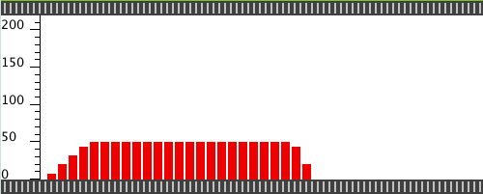 Graph f

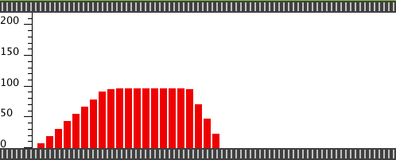 Graph g

For these two graphs, the question is which train has travelled the longest and which train has travelled the furthest. The first question is easy to answer because the computer drew more bars for Graph f. Still, the question about which train has travelled the furthest has not been answered. It is an interesting problem to present to the students in a classroom discussion. This should evoke a rich discussion. Some of them will say that travelling longer also means that you go further. Other students will not agree. One girl said: ‘the second travels further, because the difference is only 4 seconds and it’s travelling twice as fast!’
You can ask the students to try to come up with a way that will result in a more decisive answer. In the classrooms where the activity was tested, there were students who suggested to place the bars on top of each other, or to measure how long they are altogether. That is indeed a way that will result in a decisive result: the train with the longest total length has travelled the farthest.
A similar discovery lies close to what will be covered in high school education: the surface area under a line graph of the speed is a measure for the distance covered.

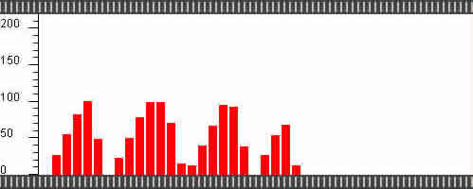 Graph h
The question for this graph is: For graph h, the program was set to ‘3 sec’. The train stopped 3 times. It really stood still. How is it possible that there is no white area in the middle, just like the other two times that the train stopped?
The intention of this question is that students realise that each bar stands for a different measurement, a moment in time. Apparently, at the second stop, there was no measurement when the train really stood still.

At train track 4, the computer draws a graph of the distance covered instead of a graph of speed. The difference between these two graphs is not easy for students. Although the graphs of speed and distance look very different, they are still related. Similar to the way that it’s possible to say something about distance from studying a speed graph, - see graphs f and g –, it is also possible to say something about the speed of the train from studying a distance graph. When the train travels fast, distance increases, which means that the graph becomes steeper.

