Webquest Train driver, Worksheets
Name/Names:

Game: How long do you take to complete one circuit?
- Play the game of Train track 1.
My best time for Train track 1 was:
‘Accelerating’ means: going faster. In a car, you accelerate by pushing your foot on the gas pedal. The train driver has a button that he presses with his finger (because a train driver does not have to use a steering wheel!).
The computer shows two buttons for accelerating. One button is for accelerating slowly, and the other is for accelerating fast. There are also two buttons for breaking: breaking slowly and breaking fast.

- Play the game of Train track 2.
My best time for Train track 2 was:

Questions for Train track 3
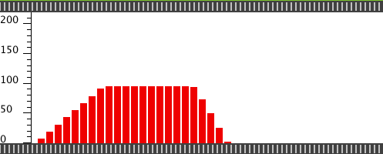 Graph a

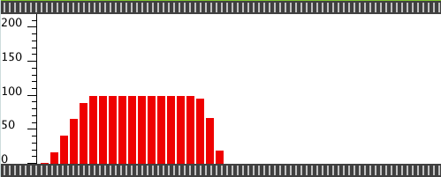 Graph b

- Make graph a on the computer
- Make graph b on the computer
- For which graph – a or b – were the buttons for quick acceleration and hard breaking used? Explain how you know.
- Does the train need the same amount of time for accelerating and breaking? Explain.

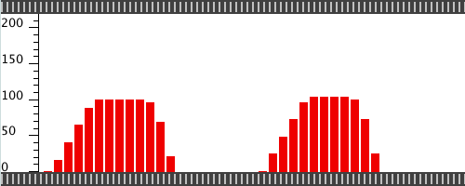 Graph c

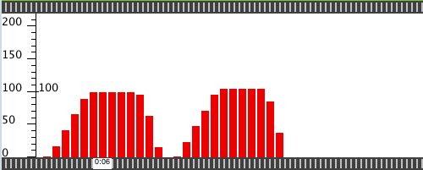 Graph d

- Make graph c on the computer
- Make graph d on the computer
- For which graph – c or d – did the train stop the longest? Explain how you know.

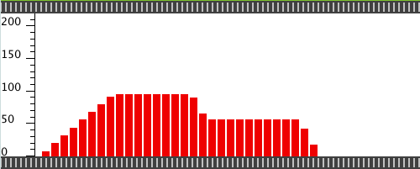 Graph e

- Make graph e on the computer. Write down what the train does in this graph

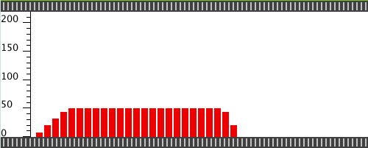 Graph f

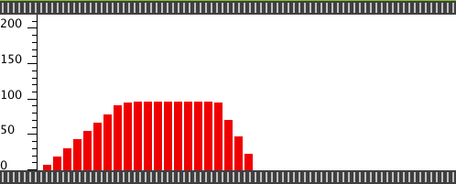 Graph g

- Make graph f on the computer
- Make graph g on the computer
- For which graph – f or g – did the train go on for longest?
- For which graph – f or g – did the train go furthest? Can you see that in the graph? Explain.

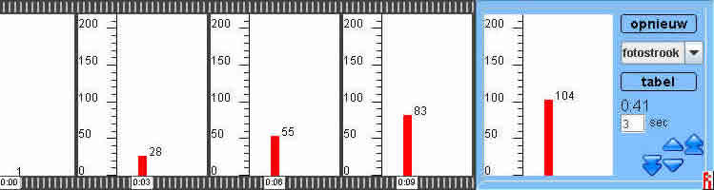

You can change things in the blue area. Try it out. In the picture above, we chose:
- ‘photo strip’ in stead of ‘bars’
- ‘3 sec’ in stead of ‘1 sec’

- Why is it called a photo strip?

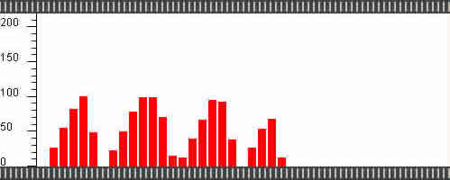 Graph h

For graph h, the program was set to ‘3 sec’. The train stopped 3 times. It really stood still.
- How is it possible that there is no white area in the middle, just like the other two times that the train stopped?
Questions about Train Track 4, distance graphs
In Train track 4 you don’t see a meter showing the speed. Instead, it shows the distance that the train has travelled.
The distance is measured in kilometres.
- What is the distance…
  - From Woezik to Bries?
  - From Bries to Hanekam?
  - From Hanekam to Middeloo?
  - From Middeloo to Klaterdal?
  - From Klaterdal to Woezik?

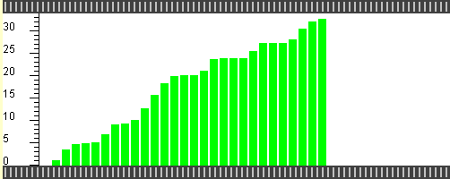 Driver Adrie
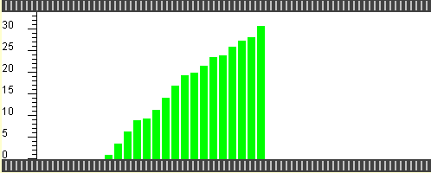 Driver Bert
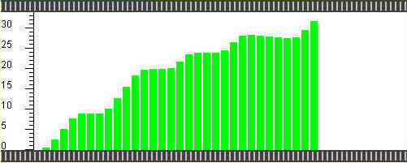 Driver Co
- Study the three pictures above.
  - One of the drivers stopped at the stations for only a very short while. What is his name?
  - One of the drivers accidentally drove by Klaterdal (the fourth station). What is his name?
  - One of the drivers drove too fast in the beginning. The train stopped automatically through the ATB. What is his name?

- Can you use the distance graph to see whether the train is going fast or slowly? Explain.

