Cube in Flatland
Here you see how a sphere goes through Flatland.
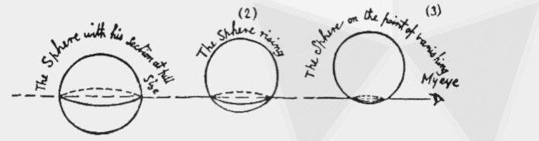
The Flatlanders first see a dot and then a circle that gets bigger and bigger and then smaller and finally disappears as a dot.
. |  |  |  |  |  | .

What happens when a cube goes through Flatland? What will the Flatlanders see?
Think about that and sketch below what the Flatlanders see.

Is there another possibility?

Cross sections of the cube with Flatland
When the cube passes through Flatland with one side, the flatlanders always see the same square.

But what if the cube goes through Flatland in a different way what do the flatlanders see? For example, if the cube goes through with a vertex first.
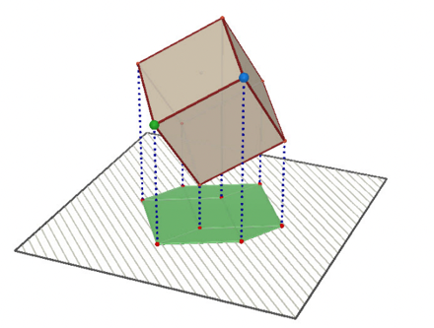

You can now do a small research what shapes the cube can take when it enters Flatland. You can splice the cube in subsequent parts.
like this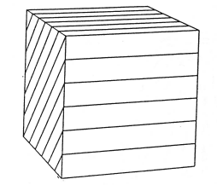or 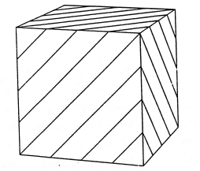or 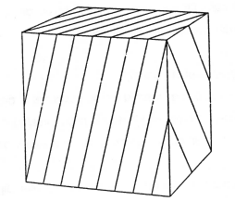 or...
You can use floral foam ('Oasis') to really make the different slices. And then you can sketch the shapes of the slices (cross sections) below.

https://en.wikipedia.org/wiki/Flatland

