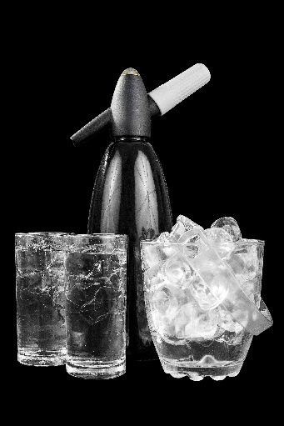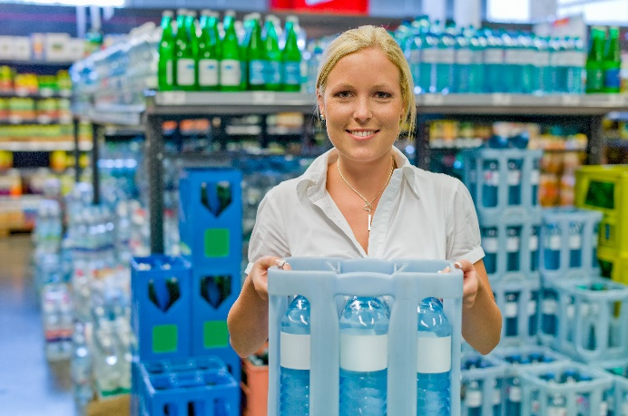

**Quarterly Problem**

*- Green Edition -*

**Water on!**

https://www.colourbox.de // PetraD

https://www.colourbox.de // [Ekaterina Oleshko](https://www.colourbox.de/supplier/ekaterinaoleshko-251855)

**Brainstorm-Box**

Tap water seems to be an inexhaustible source of drinking water for us. Even flowers are watered and toilets are flushed with drinking water. But this is not the case everywhere. Find out about tap water in other countries. Which water sources are used here instead?

*"Who helps carry groceries?" Who doesn't know this question when parents come back from the supermarket? Then it's time to carry bags, and even worse, carry water crates! If the bottles are even made of glass, you can hardly lift the crate on your own. So would you rather have plastic bottles?*

A large glass of sparkling mineral water - at least in Germany it is hard to imagine a dining table without it. But where does your water come from? From glass bottles? Plastic bottles? Reusable or disposable bottles? Or even a device for bubbling tap water? And which of these possibilities is really sustainable?

**Which of the options is the best - what do you think?** Consider the ecological footprint of the various possibilities (such as of the carbon dioxide bottle) the cost per litre and the practicability!

**→**

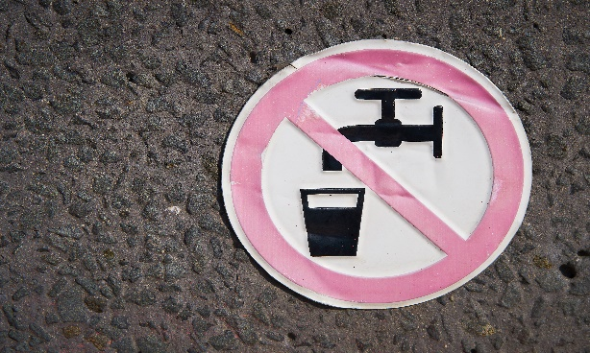



© Katharina Flößer/International Centre for STEM Education (ICSE), 2019  
CC-BY-NC-SA 4.0 License is granted

**Whose method is the most accurate?**Be sure to present your thoughts and findings in an accurate and understandable way.   
Also state on what information your estimations are based.

https://www.colourbox.de // Heiko Kueverling