# Rollstuhl, Behinderung, Paraplegiker, Verletzt

Quarterly Problem

*- Math Edition -*

Make the world a little better…

www.pixabay.com

**Brainstorm-Box**

What other material could be collected, to raise money for a good purpose? Where would you get the money from? Which purpose would you support?

**→**

*Plastic waste, environmental pollution, a virus, that keeps the whole world in suspense – isn’t there one good thing left on earth? Can we create something good out of all this?*

In Greece, many schools, organizations and municipalities collect plastic lids from milk, juice, water, and shampoo or detergent bottles. They sell these collected lids to industries that use plastic in their production. With the money gained they can e.g. buy wheel chairs for persons in need. For one wheel-chair, approximately one tone of lids is needed.

**Estimate the time needed to collect one tone of plastic lids, if all students of your school collect plastic lids for this purpose.** How long would it take, if only you and your family collect lids? Propose other ways of managing this goal in a reasonable time duration.

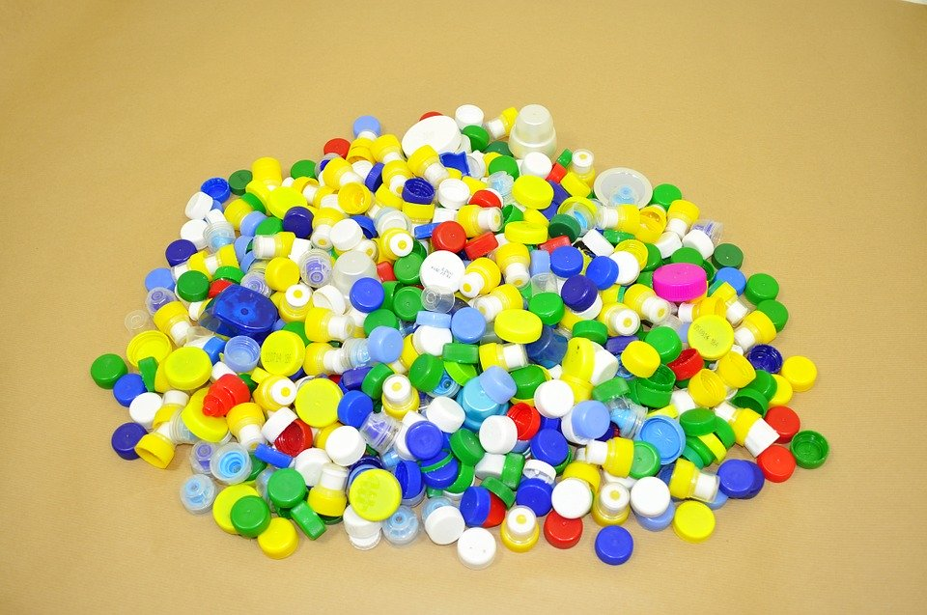

© Despina Potari, Katharina Flößer/International Centre for STEM Education (ICSE), 2019

CC-BY-NC-SA 4.0 Lizenz wird gewährt

www.pixabay.com

Whose method is the most accurate?

Focus on phrasing your approach in a clear and comprehensible way.

Also state what foundation you have used for your estimations.