# De Audio, Sonido, Patrón, Tecnología, Grabación

Quarterly Problem

*- Science Edition -*

Too noisy?

www.pixabay.com

*All humans have the capacity to pause, listen and recognize the diversity and quality of sound in any given space. Through more active listening, each of us can find a different connection to the environments we inhabit1.*

Nowaday restrictions due to COVID-19 have modified the map of sounds around us, as we used to perceive them: busy streets, schools, neightbourhoods, gardens, sport areas, or even some rooms of your home…they don´t “sound” the same as before.

**Map to sounds sourrounding you.** You can use some free mobile applications to record sounds and analyze them from a holistic point of view or from a more accurate point of view through its physical parameters. Which other ways could be used to analyse the sounds?

*[1] https://theconversation.com/listening-to-nature-how-sound-can-help-us-understand-environmental-change-105794*

**Brainstorm-Box**

Did you know that environmental sounds could be an indicator of health?

What make a sound pleasant or noisy?

**→**

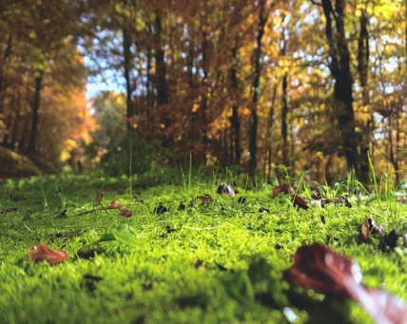



Build your map of sounds

Be sure to present your thoughts and findings in an accurate and understandable way.

Inquiry about different maps of sound regarding different places around you. It might happen that at the moment you have some restrictions to go outside (COVID-19), but it could be a good opportunity to measure sound from different places in your house or garden and shared results with your friends.

Tip: Inside your own home you can find different “maps” depending on the room, activity, hour…

https://about.canva.com/license-agreements/

www.pixabay.com

© Quesada, A. Ariza, M.R., Abril, M.R: University of Jaén & Katharina Flößer, International Centre for STEM Education (ICSE), 2020. CC-BY-NC-SA 4.0 Licensed granted