# Correo Electrónico, Boletín De Noticias

Quarterly Problem

*- Green Edition -*

Pointless messages

www.pixabay.com

**→**

*Whether with your neighbour or your buddy in Argentina - we are all connected and love communicating with each other. To do this, we use the technologies that are available to us. We use our beloved devices (e.g. mobile phones or laptops) all the time in our everyday lives, whether as alarm clocks, to play games, for homework or for work - or just to stay in contact with friends and relatives.*

Several studies have shown that a large amount of pointless e-mails and text messages are sent every day. And did you know that Internet use consumes near as much CO2 every year as air traffic1?

Obviously, the messages we send have more impact on the environment than one might think. But do all these messages really have to be sent?

**How many messages do you read and send every day?** How many of them are unnecessary? How many unnecessary e-mails/messages do you send per month? Do you usually send short messages to say "thank you", "I read it" or "hello"? Do you send the same message again and again?

Think about how you could reduce the number of text messages without neglecting your friends or seeming unfriendly.

1https://www.zdf.de/nachrichten/heute/klickscham-wie-viel-co2-e-mails-und-streaming-verusachen-100.html

**Brainstorm-Box**

How do you think emails/messages contribute to the massive carbon footprint?

What can you do to reduce/minimize CO2 emissions related to “pointless messages”?

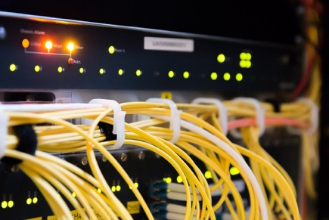

www.pixabay.com

Analyse and enact

Inquire about CO2 footprint related to message technology uses. Be sure to present your thoughts and findings in an accurate and understandable way.

You can compare the impact of your technology-based messages to other CO2 sources (e.g. different kind of transport, needed for the traditional mail).

You can also include your friends in the survey and make the analysis more “global”.



© Quesada, A. Romero, M.R., Abril, A.M. University of Jaén & International Centre for STEM Education (ICSE), 2020. CC-BY-NC-SA 4.0 Licensed granted



© Quesada, A. Ariza, M.R., Abril, A.M. University of Jaén & Katharina Flößer, International Centre for STEM Education (ICSE), 2020. CC-BY-NC-SA 4.0 Licensed granted