# 

Quarterly Problem

*- Green Edition -*

Don’t waste waste!

**Brainstorm-Box**

At home you probably separate various types of waste. Measure for each type the weekly production in kilograms. Divide the results by the number of persons in your home.

**→**

*Waste production is a global problem. Worldwide, people are looking for solutions for this. Waste is produced in various locations. How much do waste do we produce at home?*

The Eurpoean Union tries to reduce our waste production. For instance, by proposing a deposit on small plastic drinking bottles. Waste can be a problem closer to home and school: food leftover on streets and litter around schools and supermarkets.Household waste is often collected separately. At home you do this, for example, by keeping paper and glass separate and maybe you have a separate bin for vegetable, fruit and garden waste

**How much waste do you produce in a week?**

Explore with your peer students to what extent your waste production compares to the 505 kg of waste generated yearly per person in the EU (this numer also includes waste produced in supermarkets, restaurants, schools, offices ect.).<https://ec.europa.eu/eurostat/en/web/products-eurostat-news/-/ddn-20220214-1>

Do you want to come up with a plan to improve the waste situation in and around your school? Explore the assignment on:

<https://www.fisme.science.uu.nl/toepassingen/29018/>

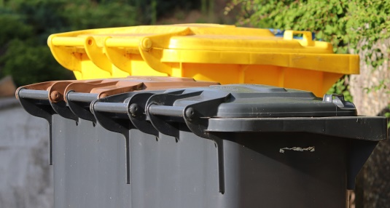

© International Centre for STEM Education (ICSE), 2022

CC-BY-NC-SA 4.0 Licence granted

Picture Source: Pixabay

Whose measuring method is the most accurate?

Focus on phrasing your approach in a clear and comprehensible way.

Also state what foundation you have used for your estimations.

© International Centre for STEM Education (ICSE), 2022

CC-BY-NC-SA 4.0 Licence granted

Picture Source: Pixabay