# 

Quartely Problem

*- Maths Edition -*

*Fancy footballs*

*In July 2022, the European Women's Football Championship is taking place in England. The matches are played with a fancy ball in bright colors. The ball does not have the classic pattern with pentagons and hexagons, but is still somehow symmetrical.*

For every European Championship and World Cup there is a newly designed ball. What would your personal ball look like for the current European Championship?

**Design your own ball for the European Championship!**

First, search the Internet for pictures of past European Championship and World Cup balls. Which shapes and colors do you like best? Also examine their symmetry: How often do the same shapes appear there and how are they distributed over the ball?

Then design your own ball. To do this, draw a sketch on a plain plastic ball or as round a balloon as you can find. Use a wipe-away pen so you can correct and change your sketch. To understand how best to distribute points evenly over the ball, it is helpful to search the Internet for pictures of the so-called "Platonic solids".

**→**

**Brainstorm-Box**

Other spherical things often have interesting symmetries as well. Look for them in your everyday life.

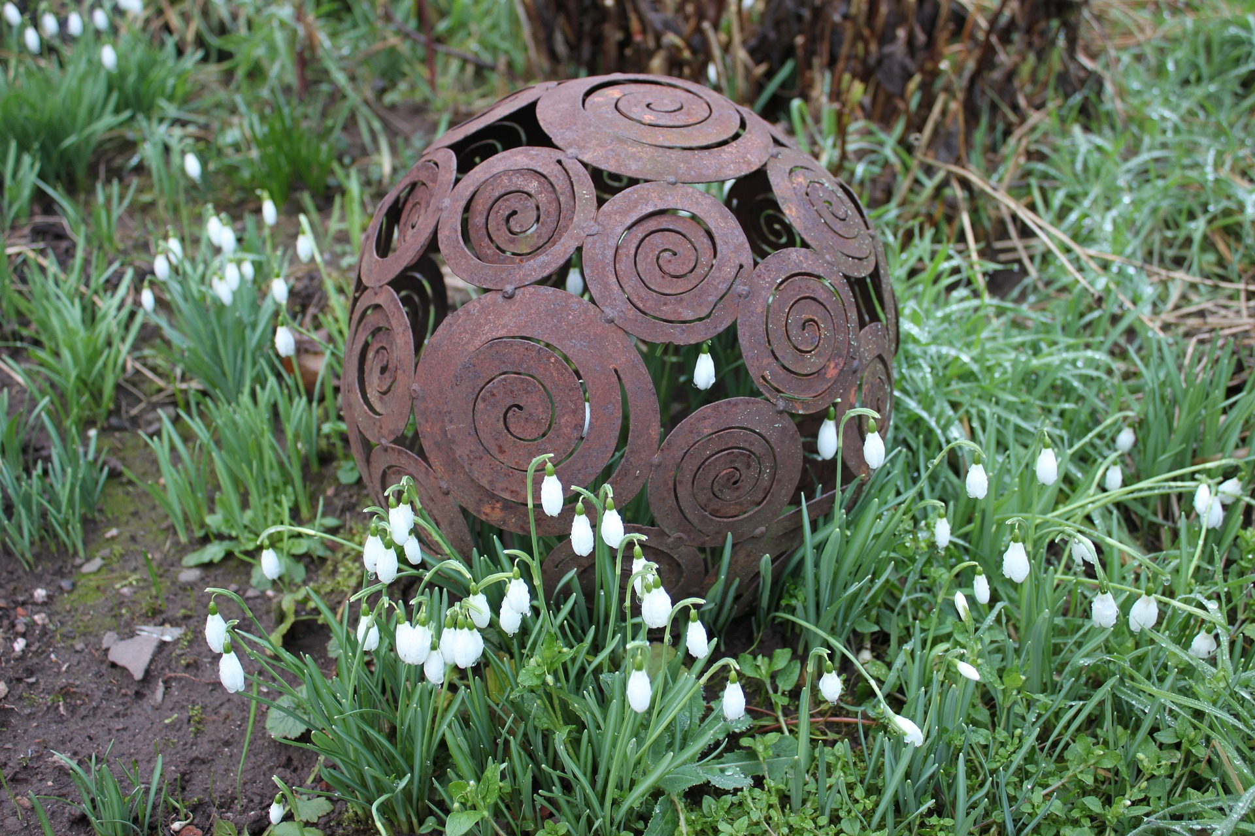



CC-BY-NC-SA 4.0 License granted

Pictures: Zdf.de/Pixabay

What symmetry does your ball have?

Are there any important points in your design that form the corners of a Platonic solid?

Are there mirror axes or rotational symmetry in the design?