Quarterly Problem

*Science Edition*

Securing the Food Supply

**Brainstorm-Box**

What are the environmental effects of pesticides? How do they affect health, biodiversity and agricultural yield?

What could be social and economic aspects to this problem?

*Our food supply is largely dependent on imports of agricultural products. The war in Ukraine, which is a major producer of wheat and oilseeds, and the resulting disruption of supply chains make us painfully aware of this. Now, some European countries are seeking greater autonomy in agricultural production and are taking effective action. For example, controversial pesticides are being approved for use again. These pesticides can contribute to yield security in the short term by reducing crop losses due to pests. However, if used improperly, they can accumulate in soils and groundwater and cause lasting damage to local life, with far-reaching consequences for the ecosystem.*

**→**

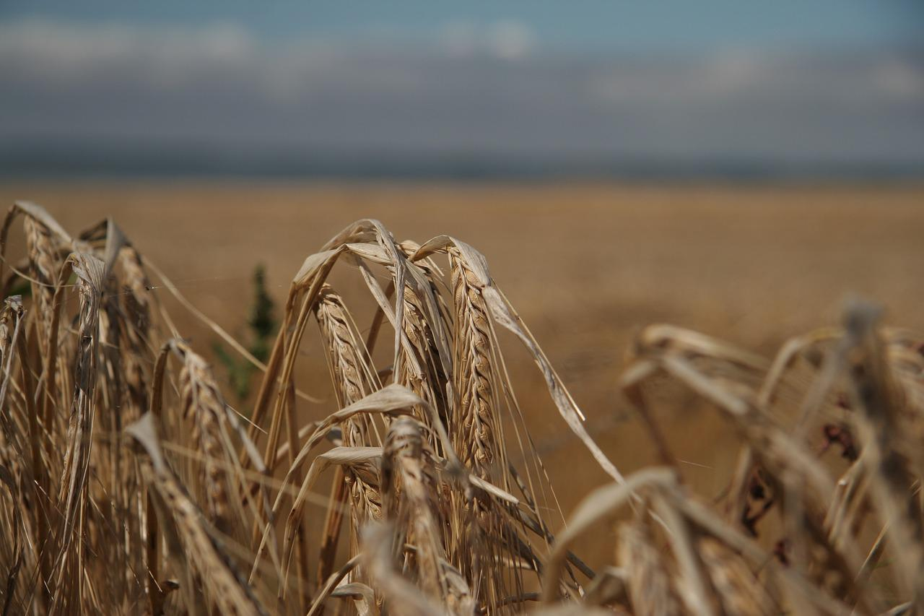



How did you come to your decision?

Describe your decision-making process.

What sources were the basis for your considerations?

How did you weigh the arguments for and against the use of pesticides?

© Christina Pichler-Koban & Andrea Frantz-Pittner, Alpen Adria Universität Klagenfurt 2022

Lizenz wird gewährt

Picture Source: Pixabay

How would you decide?

Is the short-term and targeted use of pesticides justified to secure our food supply? Or is extensive agriculture, which pollutes the soil and water less but requires a lot of land, preferable? Should areas that have been left fallow for biodiversity conservation reasons be recultivated? Who are the winners or losers in the case of using pesticides?